Digital image

A digital image is an image composed of picture elements, also known as pixels, each with finite, discrete quantities of numeric representation for its intensity or gray level that is an output from its two-dimensional functions fed as input by its spatial coordinates denoted with x, y on the x-axis and y-axis, respectively. Depending on whether the image resolution is fixed, it may be of **vector** or **raster** type. By itself, the term "digital image" usually refers to raster images or bitmapped images (as opposed to vector images).

**Vector graphics** are computer graphics images that are defined in terms of points on a Cartesian plane, which are connected by lines and curves to form polygons and other shapes. Vector graphics have the unique advantage over raster graphics in that the points, lines, and curves may be scaled up or down to any resolution with no aliasing. The points determine the direction of the vector path; each path may have various properties including values for stroke color, shape, curve, thickness, and fill.

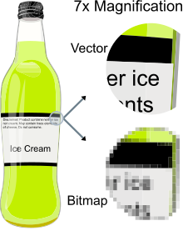Vector graphics are commonly found today in the SVG, EPS, PDF or AI types of graphic file formats, and are intrinsically different from the more common raster graphics file formats such as JPEG, PNG, APNG, GIF, and MPEG4.

In computer graphics and digital photography, a **raster graphic** is a dot matrix data structure that represents a generally rectangular grid of pixels (points of color), viewable via a computer display, paper, or other display medium. Raster images are stored in image files with varying dissemination, production, generation, and acquisition formats.

The printing and prepress industries know raster graphics as contones (from "continuous tones"). The opposite of contones is "line work", usually implemented as vector graphics in digital systems.

A **bitmap image** is a rectangular grid of pixels, with each pixel's color being specified by a number of bits. A bitmap might be created for storage in the display's video memory or as a device-independent bitmap file. A raster is technically characterized by the width and height of the image in pixels and by the number of bits per pixel.

**Common pixel** formats are monochrome, gray scale, pelletized, and full color, where color depth determines the fidelity of the colors represented and color space determines the range of color coverage (which is often less than the full range of human color vision). High-resolution digital images are storage intensive, especially at high color-depths.

**Raster images** have a finite set of digital values, called picture elements or pixels. The digital image contains a fixed number of rows and columns of pixels. Pixels are the smallest individual element in an image, holding antiquated values that represent the brightness of a given color at any specific point.

Typically, the **pixels are stored** in computer memory as a raster image or raster map, a two-dimensional array of small integers. These values are often transmitted or stored in a compressed form.

**Raster images** can be created by a variety of input devices and techniques, such as digital cameras, scanners, coordinate-measuring machines, seismographic profiling, airborne radar, and more. They can also be synthesized from arbitrary non-image data, such as mathematical functions or three-dimensional geometric models; the latter being a major sub-area of computer graphics. The field of digital image processing is the study of algorithms for their transformation.

# Digital image processing

Digital image processing is the use of a digital computer to process digital images through an algorithm. As a subcategory or field of digital signal processing, digital image processing has many advantages over analog image processing. It allows a much wider range of algorithms to be applied to the input data and can avoid problems such as the build-up of **noise and distortion** during processing.

**Distortion** is the alteration of the original shape (or other characteristic) of something. In communications and electronics it means the alteration of the waveform of an information-bearing signal, such as an audio signal representing sound or a video signal representing images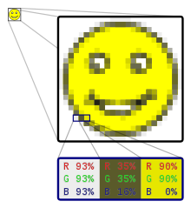.

In signal processing, **noise** is a general term for unwanted (and, in general, unknown) modifications that a signal may suffer during capture, storage, transmission, processing, or conversion.